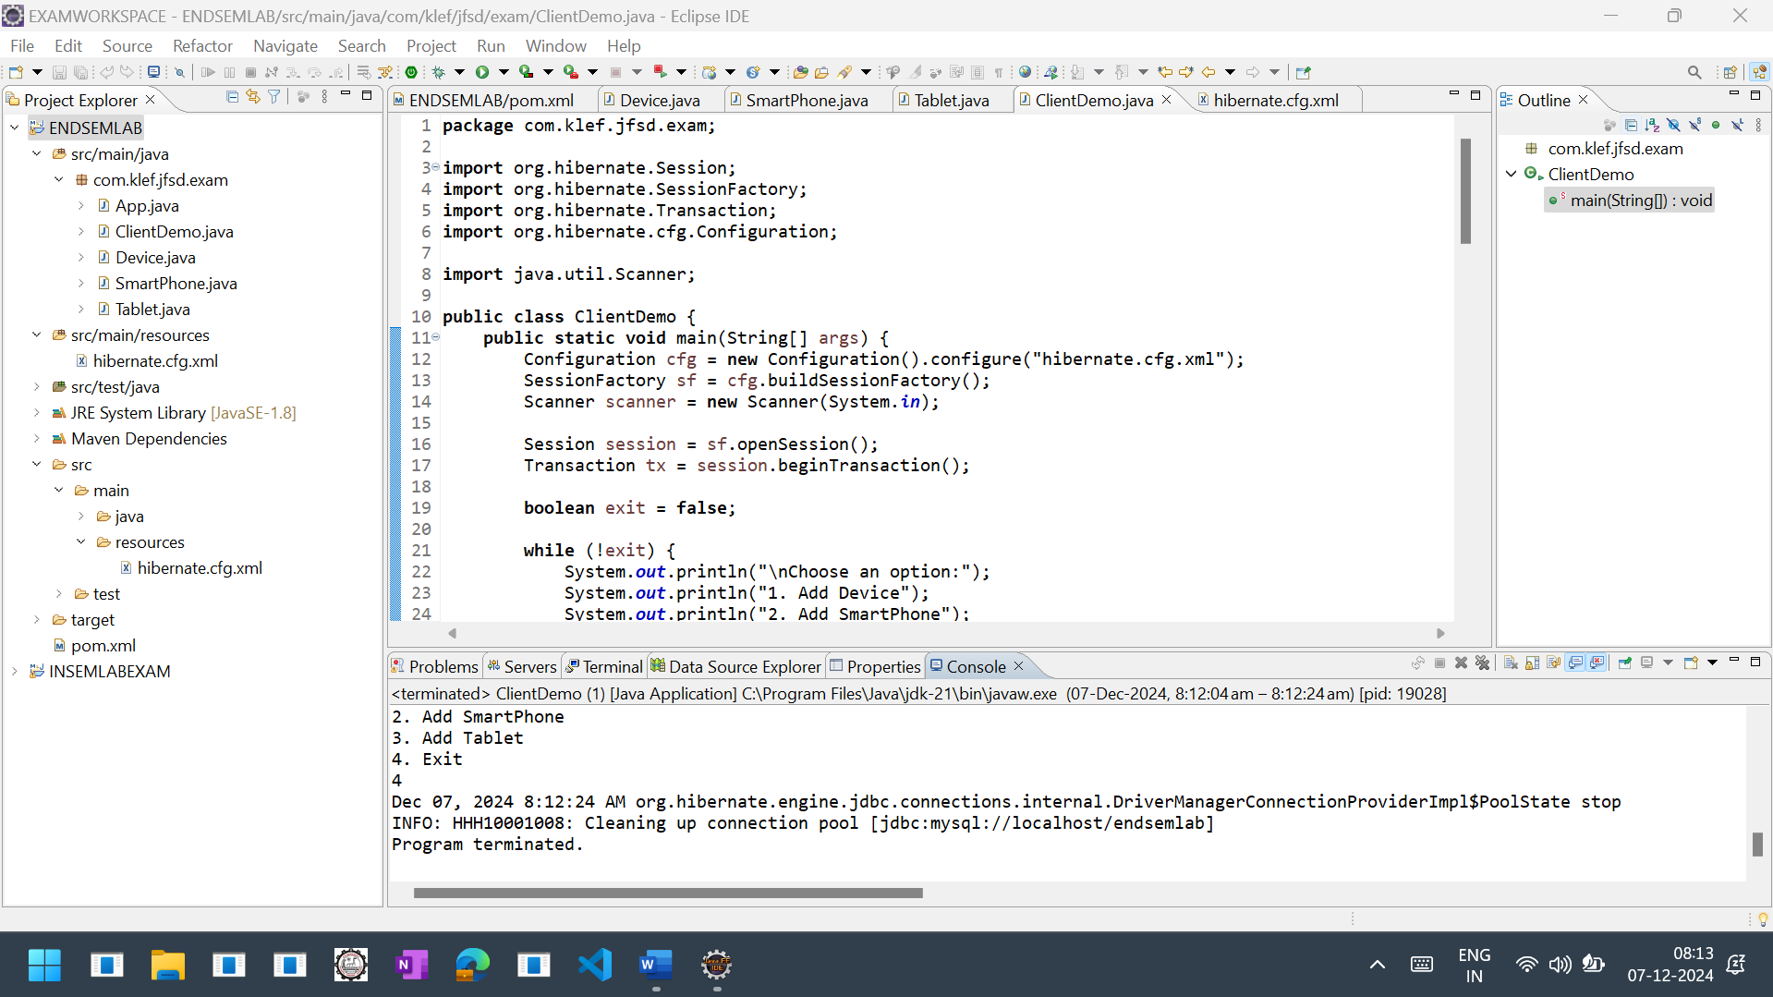

**package** com.klef.jfsd.exam;

**import** org.hibernate.Session;

**import** org.hibernate.SessionFactory;

**import** org.hibernate.Transaction;

**import** org.hibernate.cfg.Configuration;

**import** java.util.Scanner;

**public** **class** ClientDemo {

**public** **static** **void** main(String[] args) {

Configuration cfg = **new** Configuration().configure("hibernate.cfg.xml");

SessionFactory sf = cfg.buildSessionFactory();

Scanner scanner = **new** Scanner(System.***in***);

Session session = sf.openSession();

Transaction tx = session.beginTransaction();

**boolean** exit = **false**;

**while** (!exit) {

System.***out***.println("\nChoose an option:");

System.***out***.println("1. Add Device");

System.***out***.println("2. Add SmartPhone");

System.***out***.println("3. Add Tablet");

System.***out***.println("4. Exit");

**int** choice = scanner.nextInt();

scanner.nextLine();

**switch** (choice) {

**case** 1:

Device d = **new** Device();

System.***out***.println("Enter Device ID: ");

d.setId(scanner.nextInt());

scanner.nextLine();

System.***out***.println("Enter Device Brand: ");

d.setBrand(scanner.nextLine());

System.***out***.println("Enter Device Model: ");

d.setModel(scanner.nextLine());

System.***out***.println("Enter Device Price: ");

d.setPrice(scanner.nextDouble());

session.save(d);

System.***out***.println("Device added successfully!");

**break**;

**case** 2:

SmartPhone sp = **new** SmartPhone();

System.***out***.println("Enter SmartPhone ID: ");

sp.setId(scanner.nextInt());

scanner.nextLine();

System.***out***.println("Enter SmartPhone Brand: ");

sp.setBrand(scanner.nextLine());

System.***out***.println("Enter SmartPhone Model: ");

sp.setModel(scanner.nextLine());

System.***out***.println("Enter SmartPhone Price: ");

sp.setPrice(scanner.nextDouble());

scanner.nextLine();

System.***out***.println("Enter Camera Specification: ");

sp.setCamera(scanner.nextLine());

System.***out***.println("Enter Operating System: ");

sp.setOs(scanner.nextLine());

session.save(sp);

System.***out***.println("SmartPhone added successfully!");

**break**;

**case** 3:

Tablet tb = **new** Tablet();

System.***out***.println("Enter Tablet ID: ");

tb.setId(scanner.nextInt());

scanner.nextLine();

System.***out***.println("Enter Tablet Brand: ");

tb.setBrand(scanner.nextLine());

System.***out***.println("Enter Tablet Model: ");

tb.setModel(scanner.nextLine());

System.***out***.println("Enter Tablet Price: ");

tb.setPrice(scanner.nextDouble());

scanner.nextLine();

System.***out***.println("Enter Battery Life: ");

tb.setBattery(scanner.nextLine());

System.***out***.println("Enter Screen Size: ");

tb.setScreensize(scanner.nextDouble());

session.save(tb);

System.***out***.println("Tablet added successfully!");

**break**;

**case** 4:

exit = **true**;

**break**;

**default**:

System.***out***.println("Invalid choice. Please try again.");

**break**;

}

}

tx.commit();

session.close();

sf.close();

scanner.close();

System.***out***.println("Program terminated.");

}

}

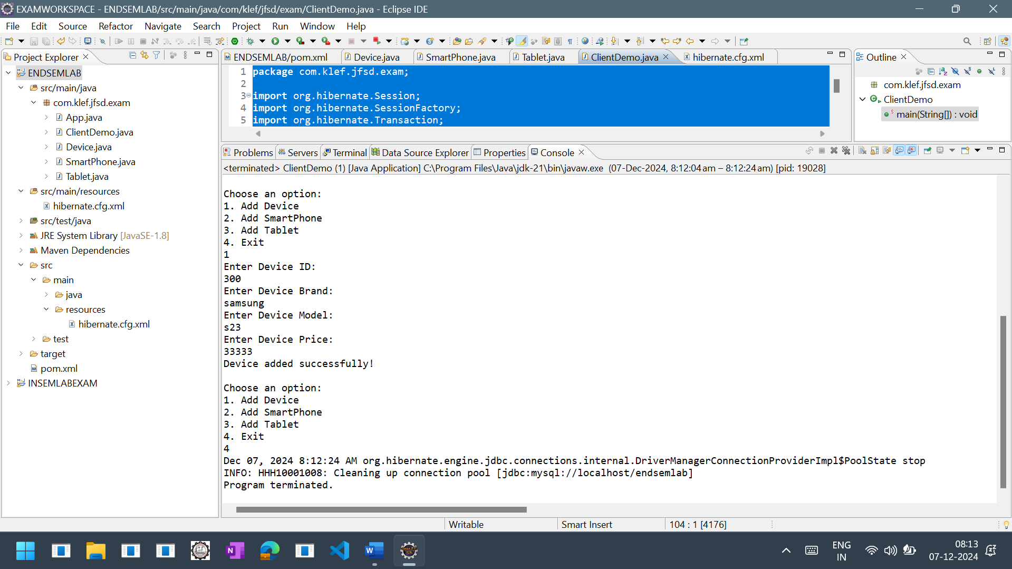

<?xml version=*"1.0"* encoding=*"UTF-8"*?>

<!DOCTYPE hibernate-configuration PUBLIC

"-//Hibernate/Hibernate Configuration DTD 5.3//EN"

"http://hibernate.org/dtd/hibernate-configuration-3.0.dtd">

<hibernate-configuration>

<session-factory>

<property name=*"hbm2ddl.auto"*>update</property>

<property name=*"dialect"*>org.hibernate.dialect.MySQL5Dialect</property>

<property name=*"connection.url"*>jdbc:mysql://localhost/endsemlab</property>

<property name=*"connection.username"*>root</property>

<property name=*"connection.password"*>admin</property>

<property name=*"connection.driver_class"*>com.mysql.cj.jdbc.Driver</property>

<mapping class=*"com.klef.jfsd.exam.Device"*/>

<mapping class=*"com.klef.jfsd.exam.SmartPhone"*/>

<mapping class=*"com.klef.jfsd.exam.Tablet"*/>

</session-factory>

</hibernate-configuration>

**package** com.klef.jfsd.exam;

**import** javax.persistence.Entity;

**import** javax.persistence.Id;

**import** javax.persistence.Inheritance;

**import** javax.persistence.InheritanceType;

@Entity

@Inheritance(strategy =InheritanceType.***JOINED*** )

**public** **class** Device {

@Id

**int** id;

String brand;

String model;

**double** price;

**public** **int** getId() {

**return** id;

}

**public** **void** setId(**int** id) {

**this**.id = id;

}

**public** String getBrand() {

**return** brand;

}

**public** **void** setBrand(String brand) {

**this**.brand = brand;

}

**public** String getModel() {

**return** model;

}

**public** **void** setModel(String model) {

**this**.model = model;

}

**public** **double** getPrice() {

**return** price;

}

**public** **void** setPrice(**double** price) {

**this**.price = price;

}

}

**package** com.klef.jfsd.exam;

**import** javax.persistence.Entity;

**import** javax.persistence.PrimaryKeyJoinColumn;

@Entity

@PrimaryKeyJoinColumn(name = "id")

**public** **class** SmartPhone **extends** Device{

String os;

String camera;

**public** String getOs() {

**return** os;

}

**public** **void** setOs(String os) {

**this**.os = os;

}

**public** String getCamera() {

**return** camera;

}

**public** **void** setCamera(String camera) {

**this**.camera = camera;

}

}

**package** com.klef.jfsd.exam;

**import** javax.persistence.Entity;

**import** javax.persistence.PrimaryKeyJoinColumn;

@Entity

@PrimaryKeyJoinColumn(name="id")

**public** **class** Tablet **extends** Device{

**double** screensize;

String battery;

**public** **double** getScreensize() {

**return** screensize;

}

**public** **void** setScreensize(**double** screensize) {

**this**.screensize = screensize;

}

**public** String getBattery() {

**return** battery;

}

**public** **void** setBattery(String battery) {

**this**.battery = battery;

}

}